The User can move the hero by using keyboard.

When the hero touches enemies, you can collect some points.

When the hero touches Bombs, you will lose some points.

You have only 60 seconds to play one game.

So, need to collect points as much as possible in one minute.

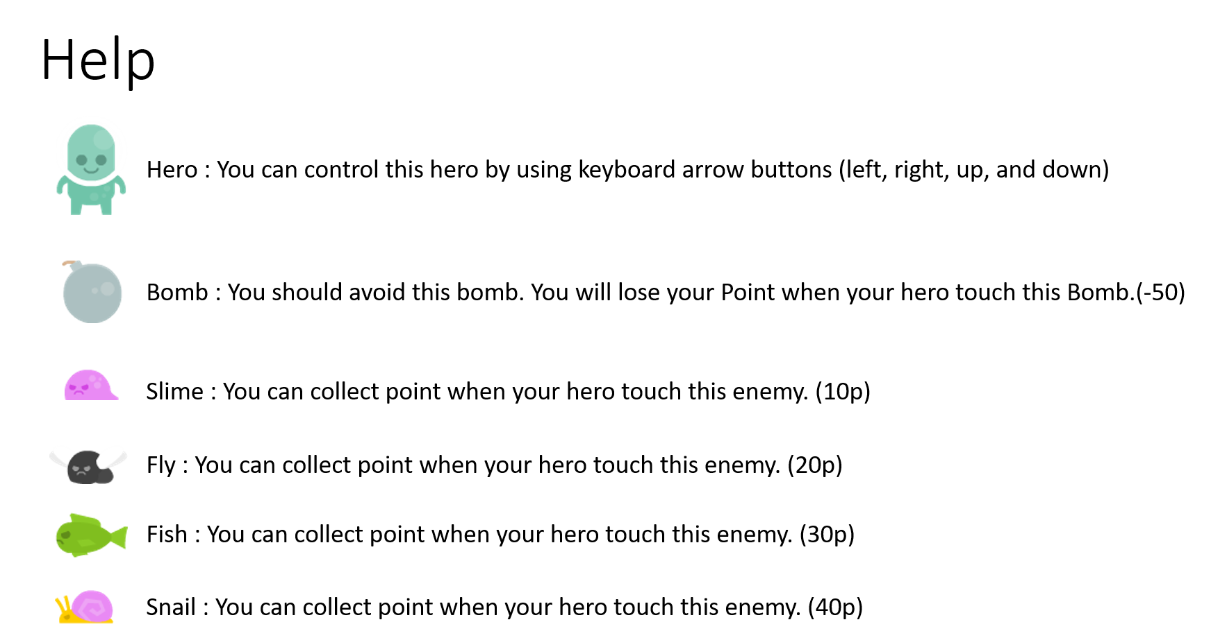

Class diagram

EndTextComponent

GameComponent

HudString

EnemyManager

DrawableGameComponent

GameScene

Hero

Score

Life

AboutTextComponent

MenuComponent

Enemies

HelpTextComponent

GameComponent

GameScene

AbooutScene

ActionScene

EndScene

HelpScene

HighScoreScene

StartScene

Reference to the resources used

Images

<https://opengameart.org/content/platformer-art-deluxe>

Author: Kenney

By [www.kenney.nl](http://www.kenney.nl)

Music

<https://opengameart.org/content/5-chiptunes-action>

Author: SubspaceAudio

Sound Effect

<https://opengameart.org/content/512-sound-effects-8-bit-style>

Author: SubspaceAudio